Francis Driscoll 05/02/2023

Using Data Science to Aid in Smuggling Interdiction

Hook

As of 2023, second to Russia, Iran is the most sanctioned country in the world largely due to efforts to dissuade the Iranian government from pursuing the development of nuclear weapons. Iran holds 10% of the worlds oil reserves, and Iran’s economy is extremely dependent on revenues from the exports of oil. In response to sanctions that prohibit oil exports, the Iranian government has become involved with huge oil smuggling programs which decrease the effectiveness of US sanctions. As of March 2023, Iranian oil exports have hit their highest level since the imposition of US sanctions in 2018, and most of these exports can be attributed to illegal smuggling by ships in the Persian Gulf. The US treasury department is seeking a brilliant data scientist to develop efficient methods to estimate the amount of oil smuggling occurring from ports in Iran in order to ensure that sanctions aimed at preventing the rise of Iran’s nuclear program are effective.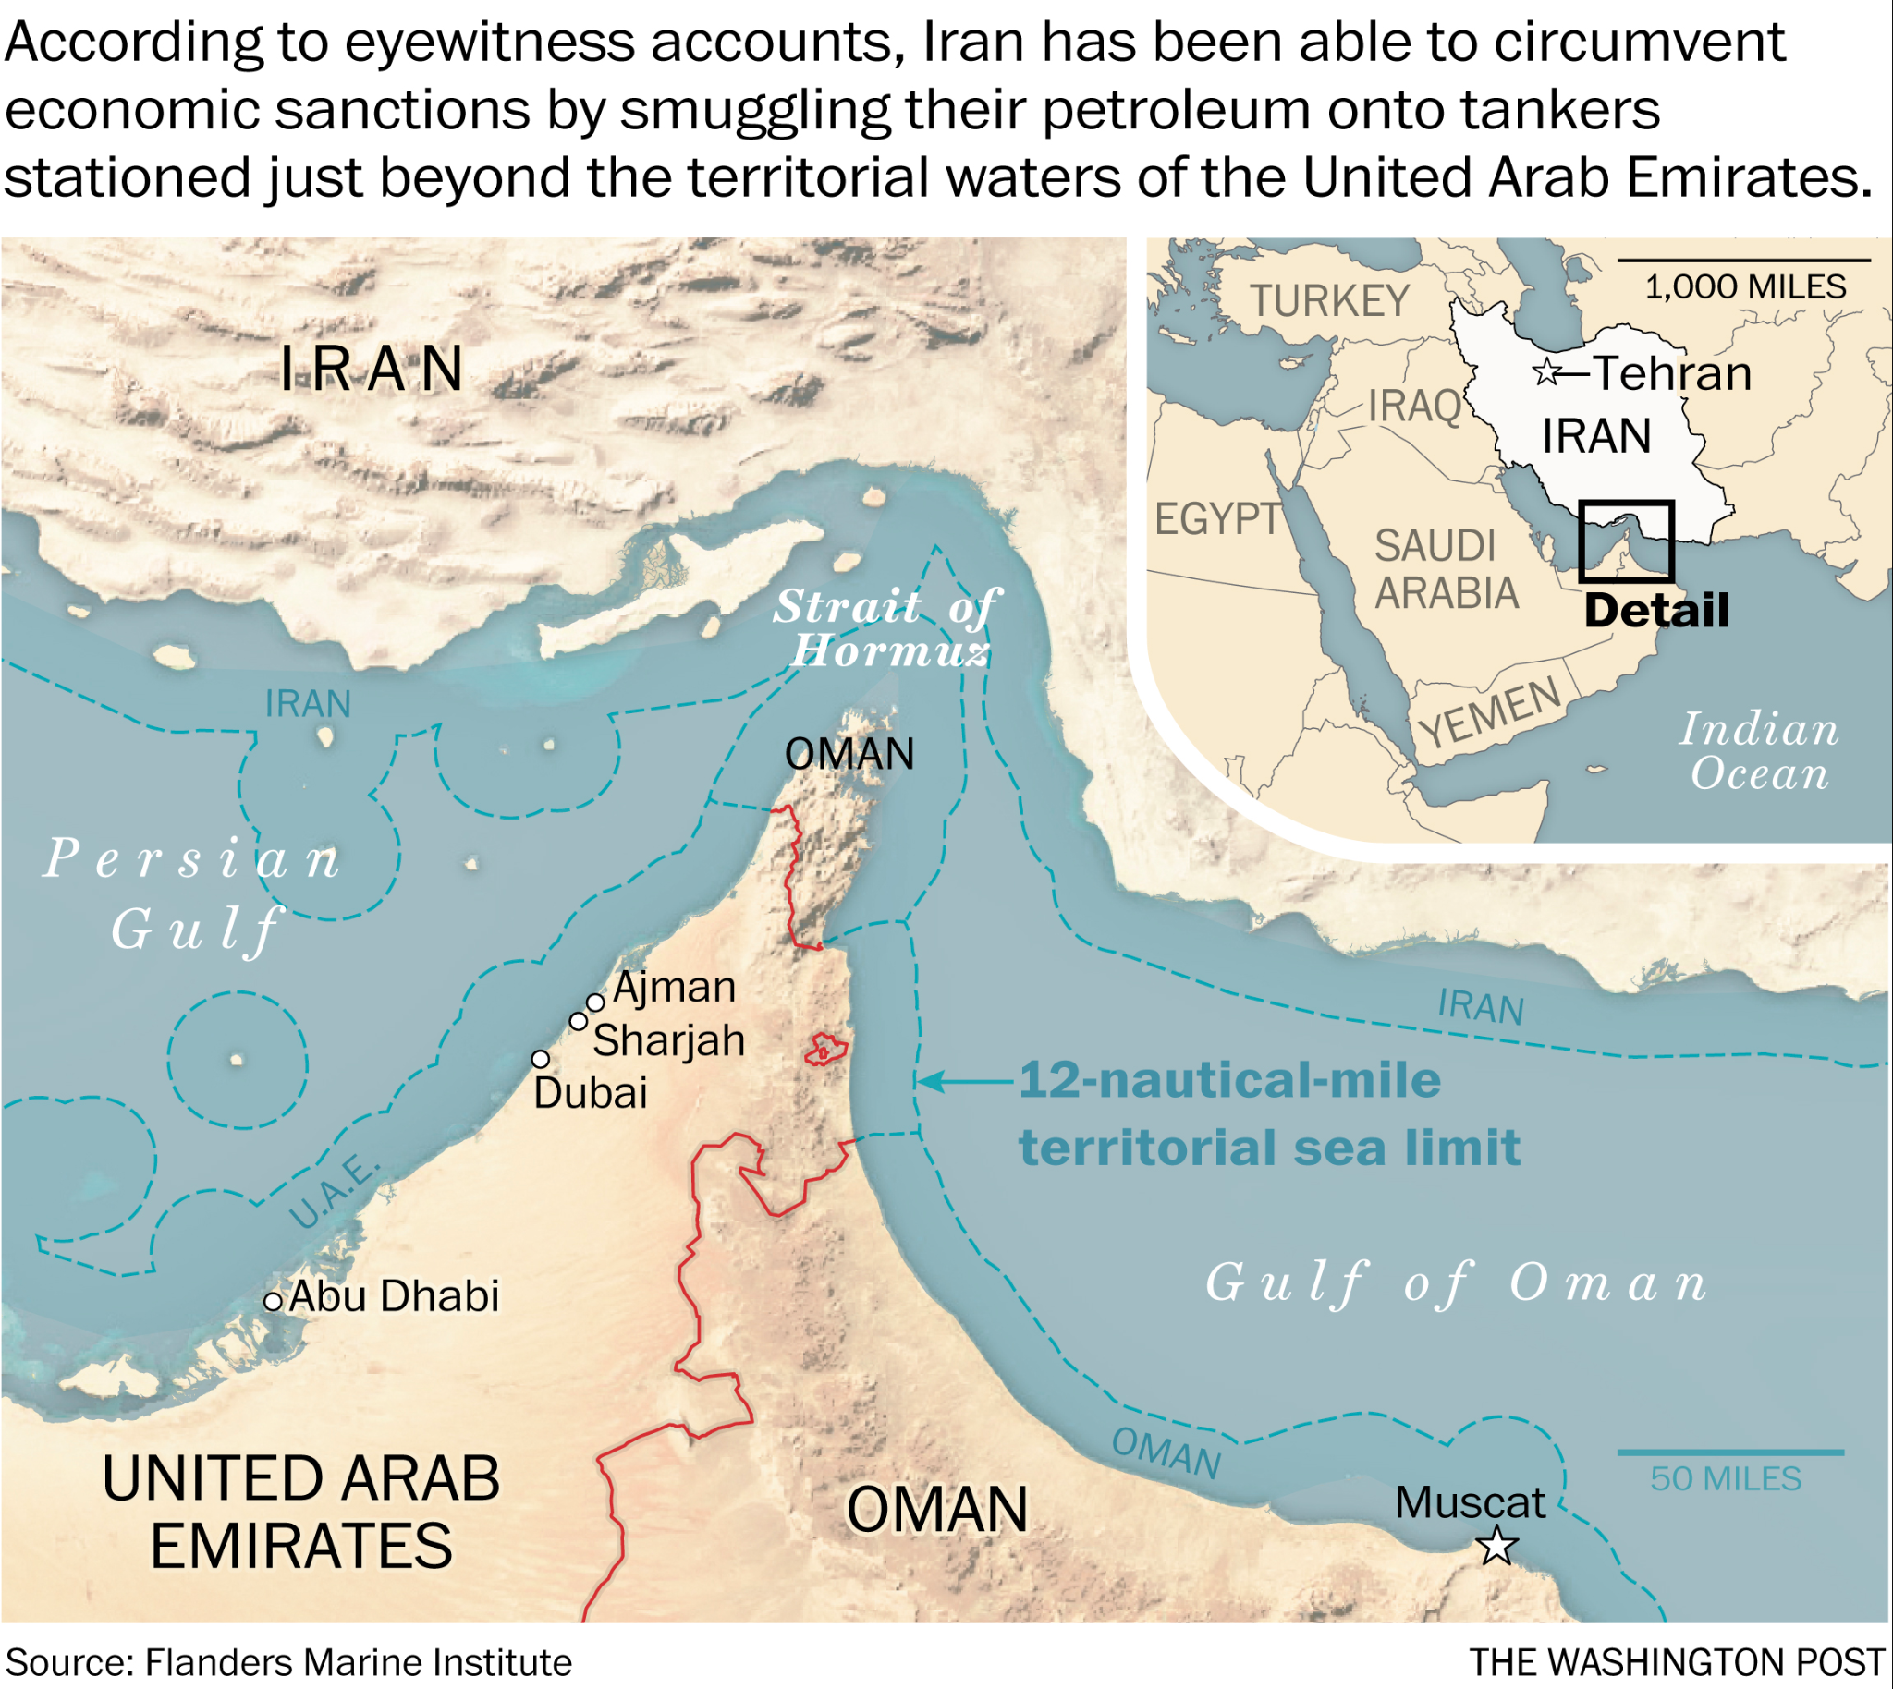

Prompt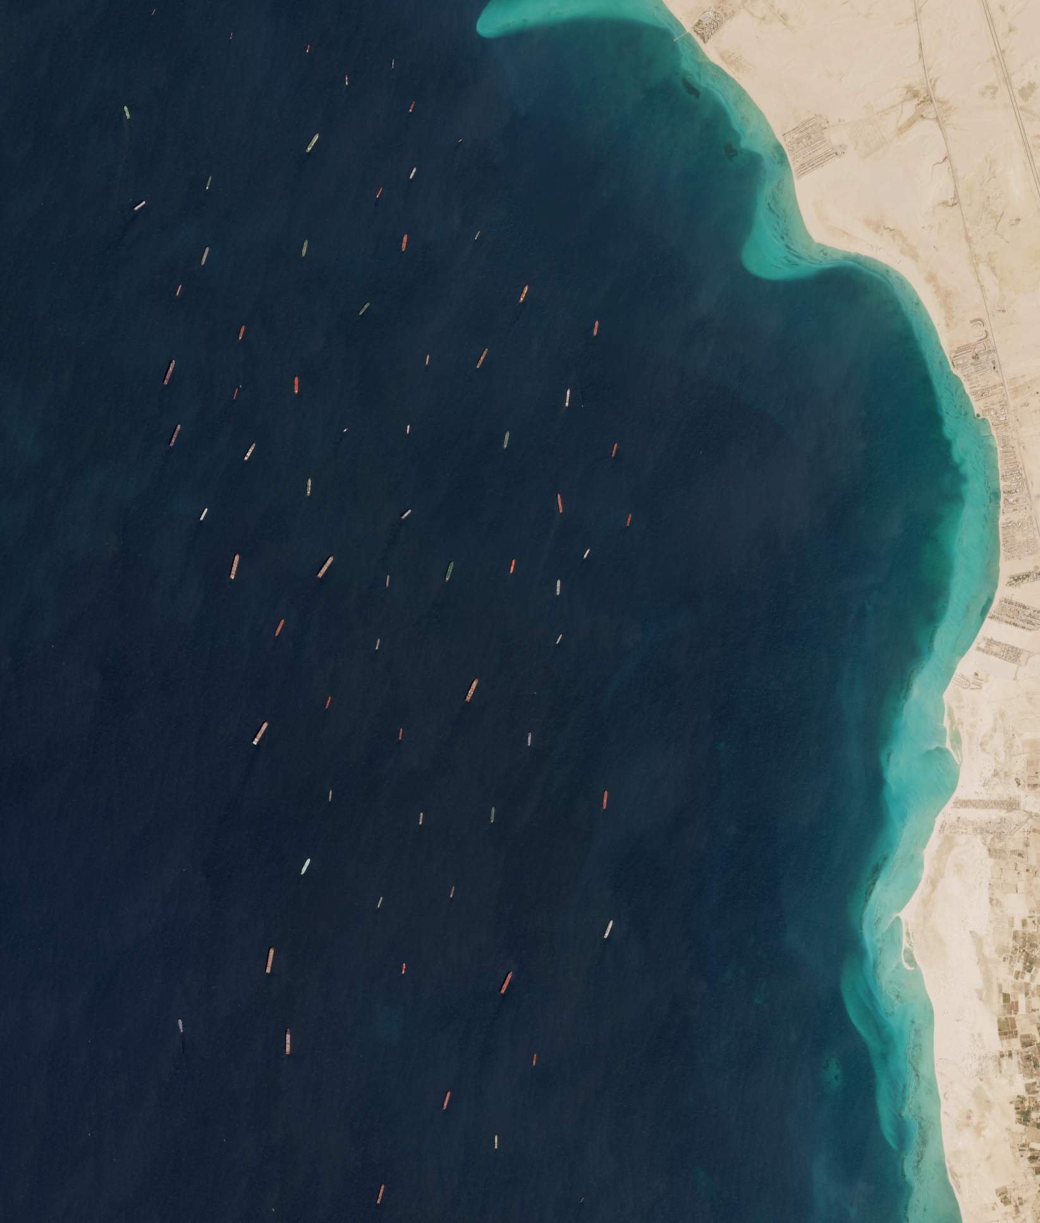

Since the US and other nations first imposed sanctions on Iran following the seizure of the American embassy in 1979, the Iranian government has implemented methods to evade sanctions and bring Iranian goods to international markets illicitly. Iranian oil tankers may change their names as they leave Iranian ports, they may transfer their oil cargoes onto other ships once at sea, or the oil tankers may turn off their Automatic Identification System (AIS) transponders which allow them to disappear from tracking systems that ships use to determine the position of other ships. As the Persian Gulf is crowded with 20% of the world’s oil trade, it is easier for ships carry iranian oil to evade authorities deployed to the Gulf to interdict smuggling. Thus, the US government is searching for a way to use satellite imagery and AIS tracking data to develop a framework for identifying ships that are likely to be smuggling.

Deliverable

The US treasury department is seeking a deliverable that includes the full scope of data science programs required to identify ships suspected of smuggling. The task is to develop a computer vision model that can identify ships from a satellite image. Once you have developed a model that can automatically identify ships, you will then use provided, hypothetical AIS data about those ships to identify suspects of smuggling. Using actual real-time satellite imagery and position data from AIS tracking websites like VesselFinder.com with the system you develop could be used in the real world to identify ships that are suspicious of illegal oil smuggling activity.